Case 1: Sales Performance Analysis
Company Background
TechSupply Co. is a regional distributor that sells electronics, office supplies, and office furniture to both retail and business customers. Management wants to better understand sales trends, customer purchasing behavior, and regional performance to improve future sales strategies.
You have been hired as a junior data analyst to explore the sales dataset and provide insights. Your task is to use Excel filtering and sorting tools to answer business questions and provide recommendations.
Dataset: use the techsupply_dataset.xlsx
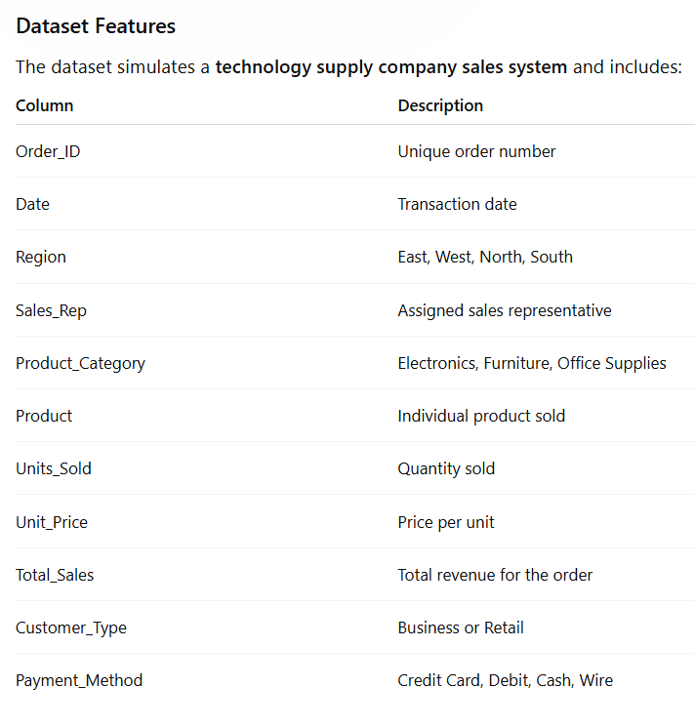

Complete the following 5 tasks.
REGIONAL PERFORMANCE ANALYSIS
Task 1: Use filters to explore sales by region.
- Filter by Region = East
- Sort Total_Sales from Largest to Smallest
Questions:
- What is the largest sale in the East region?
The largest sale in the East region is $52,950.00.

- Which product category appears most frequently?
Electronics appears most frequently in the East region.

- Which sales representative appears most often?
Brown and Johnson appear most often, with the same number of sales.

CUSTOMER BEHAVIOR ANALYSIS
Task 2: Filter by
- Customer_Type = Business
Questions
- Which product category do business customers purchase most often?
Business customers purchase Office Supplies most often.

- What is the largest business transaction?
The largest business transaction is $63,646.20 for a Laptop purchase.

- Which sales rep handles the most business orders?
Garcia and Brown handle the most business orders.

PRODUCT PERFORMANCE
Task 3: Use filters to analyze Product_Category.
Analyze each category separately:
- Electronics
- Furniture
- Office Supplies
Questions
- Which category appears to generate the highest total sales?
Furniture generates the highest total sales.

- Which specific product appears most frequently?
Filing Cabinet, Printer Paper, and Notebooks are tied as the most frequently sold products.

- Which category tends to have the largest individual transactions?
Electronics tends to have the largest individual transactions.

PAYMENT PATTERN ANALYSIS
Task 4: Filter by Payment_Method
Analyze:
- Credit Card
- Debit
- Cash
- Wire
Questions
- Which payment method is used most frequently?
Credit Card is the most frequently used payment method.

- Do business customers prefer a specific payment type?
Yes, business customers most often use Debit payments.

- Which payment type is associated with larger purchases?
Wire transfers are associated with the largest purchases.
TOP SALES REPRESENTATIVES
Task 5: Sort by:
- Sales_Rep
- Total_Sales(Largset > Smallest)
Questions
- Which sales rep appears to handle high-value transactions?
Garcia appears to handle the highest-value transactions.

- Which rep appears most frequently in the dataset?
Brown appears most frequently in the dataset.

- Which region do they appear to sell in most often?
Brown appears most often in the East region.
ANALYST RECOMMENDATION
Imagine you are presenting your findings to management.
Answer the following:
- Which region appears to be the strongest market?

The East region appears to be the strongest market because it has the highest total sales.

- Which product category should the company promote more?

The company should continue promoting Furniture because it generates the most revenue.

- Are business customers or retail customers more valuable?

Retail customers are slightly more valuable because they generate more total sales overall.

- What two recommendations would you give the sales manager?
Increase marketing and inventory for Furniture products since they produce the highest sales. Use the successful strategies from the East region in other regions to help increase overall sales.

Bonus
Build
- Bar Chart – Sales by Product Category
- Pie Chart – Customer Type Distribution
- Column Chart – Sales by Region
What story does the data tell?

